**Rationales among Iraqi people concerning non-vaccination; COVID-19 as an example**

**Dr. Ziyad Hazim Ibrahim**

Specialist in Community Medicine, Iraqi Ministry of Health, Baghdad, Iraq.

**ABSTRACT**

**Introduction:** The need for vaccines is very important. The hesitancy in taking any vaccine by the community is considered as a big challenge in the infectious disease- control generally. **Aim:** To identify the causes & worries that could give rise to non- vaccination among Iraqi people. **Methods:** A descriptive cross-sectional study carried out by selecting adult attendants of 2 health centers from 5 health districts in Baghdad for 3 months. The status of COVID- 19 immunization, reasons and beliefs among non-vaccinated, and their characteristics were included in the distributed questionnaire. **Results:** The percent of non-vaccinated participants was 49.1% (among total of 503). The most reasons of non-vaccination were because they thought that it had future harms (27.1%), and side effects (19%). About their fears, 29.9% imagined they might die after 2 years, and 29.6% just refused it even without any specific fears. Regarding the non-vaccinated characteristics, 69.7% were female, the age of 78.1% was <45, 82.6% were married, 78.1% graduated from primary or secondary school, 71.7% with no job, 83% lived in urban area, 75.7% had no chronic disease, and 87.5% had no drug allergy. There is a significant association between non-vaccination and: sex, occupation, education, and living area. **Conclusions:** Most of the non-vaccinated participants in Baghdad had wrong concepts. Those who were: female, graduated from primary school, had no job, and living in urban area are more prone not to take the vaccine. **Recommendations:** Vigorous continuous health educational programmes in Iraq about benefits and safety of vaccines are required.

**Keywords:** Non vaccination, Reasons, Beliefs.

**INTRODUCTION**

The need for vaccines is very important. Vaccines prevent viruses & bacteria from their transmission. [1, 2] They decrease the possible complications of any vaccine- preventable disease. [3] Vaccination is a simple, safe, and effective way for protecting people against harmful infectious diseases. [4] There are more than 20 vaccine- preventable diseases, as: COVID-19, DTP (Diphtheria, Tetanus, Pertussis), Hepatitis, Haemophilus Influenzae type-b, Influenza, MMR (Measles, Mumps, Rubella), Poliomyelitis, Rabies, Rotavirus, Tuberculosis, and Typhoid. [3] People in various societies could decide to take vaccines, depending on their general understanding and beliefs. [5] Public and individual beliefs could minimize immunization acceptance. [6] The hesitancy in taking any vaccine by the community is considered as a big challenge in the infectious disease- control generally. [7] The acceptance level of immunization is varying and unsteady around the world. [8] The objectives of this study are: (1) To identify the causes & worries that could give rise to non- vaccination among Iraqi people. (2) To determine some epidemiological characteristics & their possible relation in non-vaccinated people.

**METHODS**

This work is a three- month cross sectional descriptive study done in Baghdad throughout selecting adult (≥18 years) attendants of two health centers from five health districts, which are: Al- Sadr Health District, Al- Madain Health District, and Al- Shaab Health District (from the eastern side of Baghdad; Al- Rasafa), and Abu-Ghraib Health District and Al-Taji Health District (from the western side of Baghdad; Al- Karkh) during four working days per a week in all the involved ten health centers through June to August 2023 (Figure 1). The distributed questionnaire included questions about status of immunization against COVID- 19, reasons and fears about the vaccine among non- immunized ones, in addition to their epidemiological characteristics.

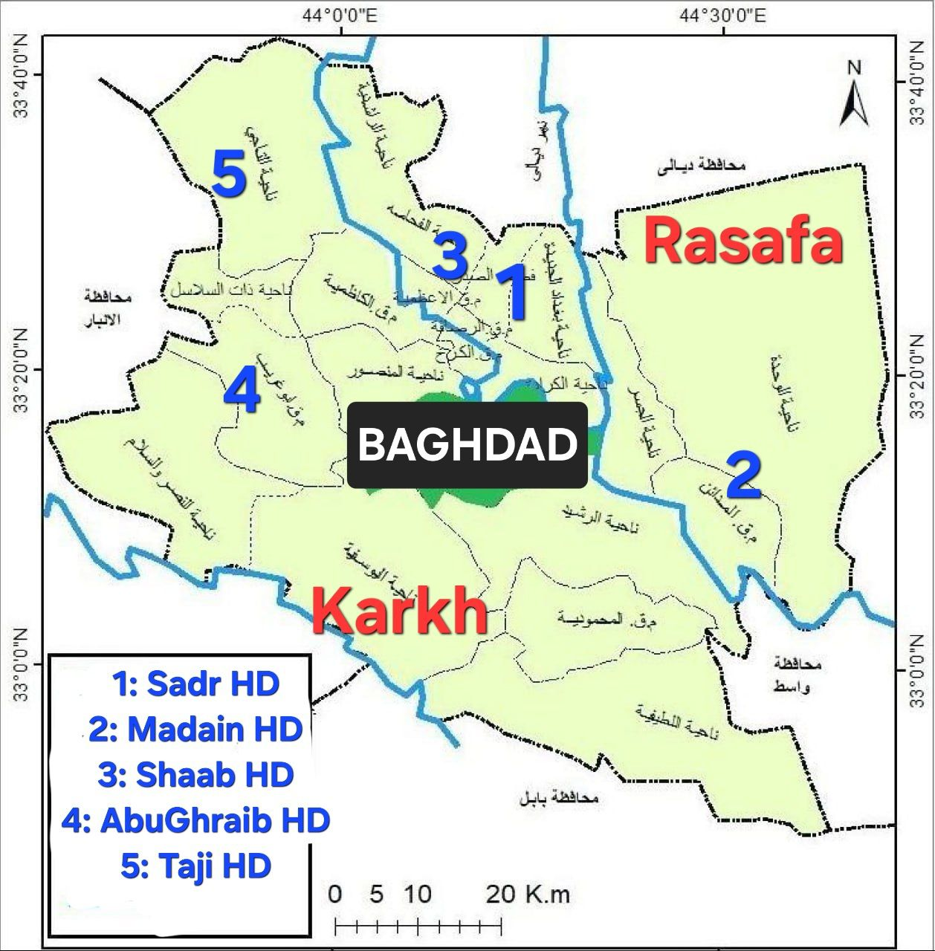

**Figure 1: The study setting and sample selection, Baghdad, 2023, N=503. Picture adopted from: Ar.Wikipedia [internet] Cited in Nov. 2023. Available at: https://ar.wikipedia.org/wiki/%D9%85%D9%84%D9%81:%D8%AE%D8%A7%D8%B1%D8%B7%D8%A9_%D9%86%D9%88%D8%A7%D8%AD%D9%8A_%D9%85%D8%AD%D8%A7%D9%81%D8%B8%D8%A9_%D8%A8%D8%BA%D8%AF%D8%A7%D8%AF.jpg**

**RESULTS**

The total obtained sample size after three months duration was 503 persons, of them 49.1% were not immunized (Figure 2).

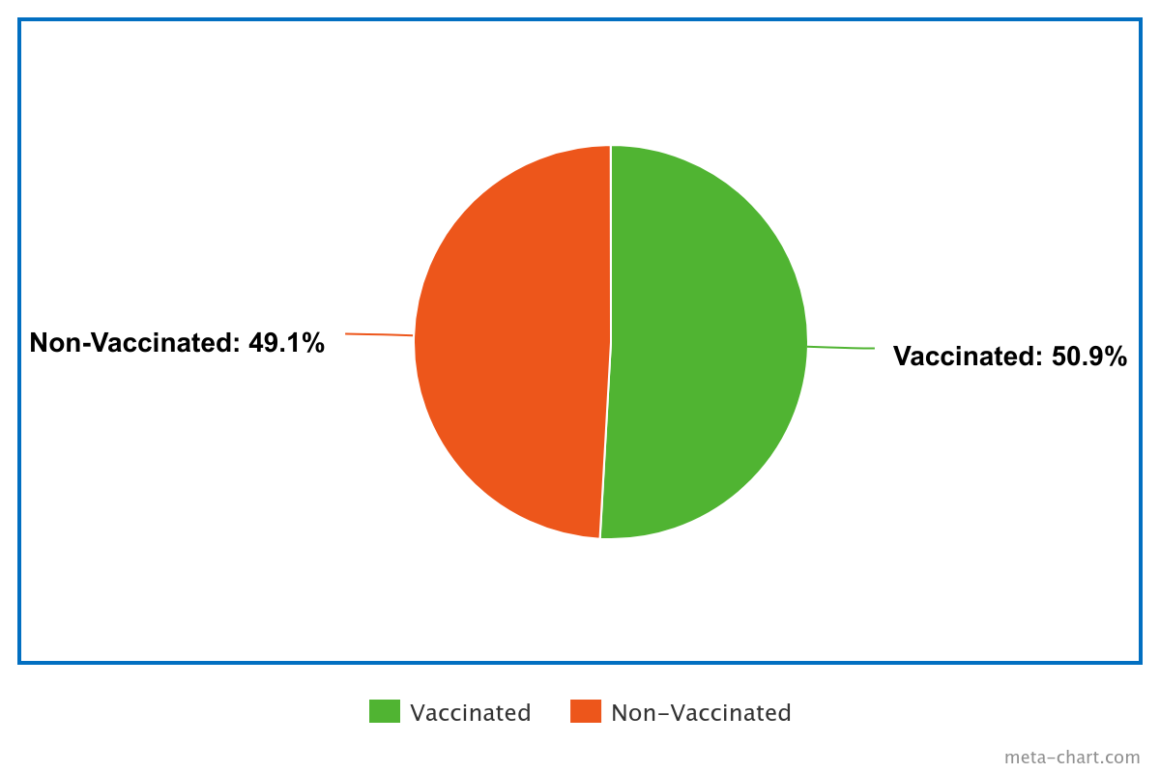

**Figure 2: The percent of non- vaccination**

Table 1 shows the reasons about non immunization (in which there were 27.1% who did not vaccinated because they thought that the vaccine had future harms, and 19% said that they refuse it because of its probable side effects), while table 2 explains the fears of non- immunized participants about the vaccine (29.9% of the them imagined that they might die after two years of vaccine taking, and 29.6% said that they just refused the vaccine even they had no specific fears about it).

**Table 1: Reasons of non- vaccination**

|  |  |  |  |
| --- | --- | --- | --- |
| **Variable (n=247)** | | **No.** | **Percent** |
| **1** | Because of the future harm from the vaccine | 67 | 27.1% |
| **2** | Due to vaccine probable side effects | 47 | 19% |
| **3** | I think the vaccine is ineffective | 33 | 13.4% |
| **4** | Because I already adhere to precautionary measures | 26 | 10.6% |
| **5** | I don't have an answer to this question | 22 | 8.9% |
| **6** | Because I am already pregnant or lactating | 22 | 8.9% |
| **7** | Because the vaccine may exacerbate the chronic diseases I have | 15 | 6.1% |
| **8** | Because I'm afraid of needles | 10 | 4% |
| **9** | Because I am allergic to some medications | 3 | 1.2% |
| **10** | I do not need the vaccine because my family or relatives have received it | 2 | 0.8% |

**Table 2: Fears about the vaccine among non-immunized participants**

|  |  |  |  |
| --- | --- | --- | --- |
| **Variable (n=247)** | | **No.** | **Percent** |
| **1** | Because I fear that I will die two years after taking the vaccine | 74 | 29.9% |
| **2** | I have no specific fear, but just don't want to take the vaccine | 73 | 29.6% |
| **3** | I am afraid of receiving the vaccine because I think it does not help at all | 54 | 21.9% |
| **4** | My fear about the vaccine is that it is a profit-making conspiracy | 21 | 8.5% |
| **5** | I am afraid of taking the vaccine because it may cause the disease | 14 | 5.7% |
| **6** | Because I do not trust government centers and the method of storing the vaccine | 6 | 2.4% |
| **7** | Because I think that the vaccine may cause infertility | 5 | 2% |

Table 3 shows the number, percent, and association between participants’ characteristics and their immunization status, in which there is a significant statistical association between the non-vaccination status and each of the sex, occupation, education, and the type of living area.

**Table 3: Number, percent, and association between participants’ characteristics and their vaccination status**

|  |  |  |  |  |  |
| --- | --- | --- | --- | --- | --- |
| **Variable** | | **Total No. (%) N=503** | **Non-vaccinated No. (%) n=247** | **Chi square** | ***p-* value** |
| **Sex** | **Male** | 208 (41.4%) | 75 (30.3%) | 24.1 | 0.000  **\*** |
| **Female** | 295 (58.6%) | 172 (69.7%) |
| **Age** | **˂ 45** | 369 (73.4%) | 193 (78.1%) | 5.6 | 0.017 |
| **≥ 45** | 134 (26.6%) | 54 (21.9%) |
| **Marital status** | **Single** | 71 (14.1%) | 35 (14.2%) | 7.4 | 0.058 |
| **Married** | 408 (81.1%) | 204 (82.6%) |
| **Divorced** | 11 (2.2%) | 1 (0.4%) |
| **Widowed** | 13 (2.6%) | 7 (2.8%) |
| **Education** | **Illiterate** | 34 (6.8%) | 23 (9.3%) | 41.8 | 0.000  **\*** |
| **Read& write** | 10 (2%) | 2 (0.8%) |
| **Primary** | 185 (36.8%) | 108 (43.7%) |
| **Secondary** | 159 (31.6%) | 85 (34.4%) |
| **≥University** | 115(22.8%) | 29 (11.8%) |
| **Occupation** | **Governmental** | 151 (30%) | 29 (11.8%) | 90.4 | 0.000  **\*** |
| **Private** | 2 (0.4%) | 1 (0.4%) |
| **No job** | 267 (53.1%) | 177 (71.7%) |
| **Own’s job** | 69 (13.7%) | 37 (14.9%) |
| **Retired** | 14 (2.8%) | 3 (1.2%) |
| **Living area** | **Rural** | 106 (21.1%) | 42 (17%) | 4.8 | 0.02  **\*** |
| **Urban** | 397 (78.9%) | 205 (83%) |
| **Having chronic diseases** | **Yes** | 110 (21.9%) | 60 (24.3%) | 1.6 | 0.19 |
| **No** | 393 (78.1%) | 187 (75.7%) |
| **Drug allergy** | **Yes** | 54 (10.7%) | 31 (12.5%) | 1.6 | 0.19 |
| **No** | 449 (89.3%) | 216 (87.5%) |

**DISCUSSION**

As mentioned in the RESULTS section, less than half of the participants were never took any dose of COVID- 19 vaccine. The most reasons of non-vaccination (in about half of them) were because of the probable future harm or probable side effects of the vaccine as they believed. Some of them (about thirteen percent) thought that the vaccine is ineffective. Only about ten percent said that they did not receive the vaccine because they were already taking their precautions. Concerning their fears from the vaccine, some of the non-vaccinated participants (about one- third) thought that they might die after two years of taking the vaccine, some (about quarter) of them thought that the vaccine is not helpful at all, and small number thought that the vaccine itself might cause the disease (about five percent) or might cause infertility for them (about two percent). Unfortunately, some of them (about two percent) reported that they did not trust the governmental health centers or the manner that the vaccine had be stored at them. Nevertheless, some of the non-vaccinated participants said that they never had specific fears but however they did not get it. Another similar Iraqi study manifested that most of its participants (78.6%) had concerns about the vaccine side effects in the future, and more than half of them (55.7%) thought that it has no any benefit effect. [9] In another Iraqi study, it was appeared that the majority of the participants (90.3%) had concerns about the adverse effects of the vaccine. [10] There is evidence in a study done in Saudi Arabia shows that about forty percents of involved participating persons said that the vaccine could be unsafe, and sixty percent of them had fears about possible side effects of it. [11] Regarding the personal, sociodemographic, and clinical characteristics among the non-vaccinated participants in our current work, most of them (about 70%) were female, the age of majority of them (about 78%) was less than forty five years, the majority (about 82%) were married, most of them (about 78%) graduated from primary or secondary school, most of them (about 71%) said that they had no job, the majority (83%) were living in urban area, and most of them had no any chronic disease (about 76%) and no any drug allergy (about87%). Our current study also showed that there is an association between non-vaccination status and both of sex, education, occupation, and the type of living area. Those who were: female, graduated from primary school, had no job, and living in urban area, are more prone not to take the vaccine than others. Those findings are agreed with that of another Iraqi study which showed that the rate of vaccination acceptance was 56.2%, with a greater rate through males. [9] Also another Iraqi study manifested that the educational status was associated with vaccine acceptance. [10] The findings of a similar Japanese study presented a significant association between vaccine refusal and female sex (as that of our work) [12] , in contrast to a Brazilian study which showed no association between those two variable. [13] A similar study done in Saudi Arabia also found that sex was associated with vaccination coverage, where females had more rates in vaccination refusal. [11] Although the educational status was revealed to be associated with the status of non-vaccination in the current study, they had no such association in the mentioned Japanese and Brazilian studies sequentially, [12, 13] but the above-mentioned Saudi study showed that educational status also associated with immunization status, where those who had university or more level had more vaccination refusal. [11]

# CONCLUSION

# Most of the non- immunized participants in Baghdad had wrong concepts about the vaccines, in which they were afraid from future harms, side effects, and fearing from dying after two years as they thought. The sex, occupation, education, and living area were significantly associated with the non-vaccination status.

# RECOMMENDATIONS

# Vigorous continuous health educational programmes about benefits and safety of the vaccines are required either inside the institutions of Iraqi Ministry of Health or outside them.

# REFERENCES

# Anne Schuchat,Human Vaccines and Their Importance to Public Health,Procedia in Vaccinology,Volume 5, 2011,Pages 120-126, ISSN 1877-282X

# Ada, G. Overview of vaccines and vaccination. *Mol Biotechnol* 29, 255–271 (2005). https://doi.org/10.1385/MB:29:3:255

# Susanna Esposito, Paolo Durando, Samantha Bosis, Filippo Ansaldi, Claudia Tagliabue, Giancarlo Icardi,Vaccine-preventable diseases: From paediatric to adult targets, European Journal of Internal Medicine,Volume 25, Issue 3,2014,Pages 203-212, ISSN 0953-6205, https://doi.org/10.1016/j.ejim.2013.12.004.

# Pollard, A.J., Bijker, E.M. A guide to vaccinology: from basic principles to new developments. *Nat Rev Immunol* 21, 83–100 (2021). https://doi.org/10.1038/s41577-020-00479-7

# Peretti-Watel P, Larson HJ, Ward JK, Schulz WS, Verger P. Vaccine hesitancy: clarifying a theoretical framework for an ambiguous notion. PLoS Curr. 2015 Feb 25;7:ecurrents.outbreaks.6844c80ff9f5b273f34c91f71b7fc289. doi: 10.1371/currents.outbreaks.6844c80ff9f5b273f34c91f71b7fc289. PMID: 25789201; PMCID: PMC4353679.

# Altulahi N, et al. Willingness, Beliefs, and Barriers Regarding The COVID-19 Vaccine in Saudi Arabia: A Multiregional Cross- Sectional Study. BMC Family Practice Journal. 2021 Dec; 22 (1) :247.

# Jonathan L., Andree H. Cognitive Barriers to COVID-19 Vaccine Uptake Among Older Adults. Frontiers in Medicine. 2021; 8, 756275.

# Huang C, Yang L, Pan J, Xu X, Peng R. Correlation between vaccine coverage and the COVID-19 pandemic throughout the world: based on real-world data. The journal of Medical Virology. 2022; 94: 2181-2187. [doi:10.1002/jmv.27609](https://doi.org/10.1002/jmv.27609)

# Magadmi, R.M., Kamel, F.O. Beliefs and Barriers Associated with COVID-19 Vaccination Among the General Population in Saudi Arabia. BMC Public Health. 2021; 21, 1438.

# Lazarus JV, Wyka K, White TM, Picchio CA, Rabin K, Ratzan SC, Parsons Leigh J, Hu J, El-Mohandes A. Revisiting COVID-19 Vaccine Hesitancy Around the World Using Data From 23 Countries in 2021. Nature Communications Journal. 2022; 13 (1): 3801.

# Gonzales, A, Lee, E, Grigorescu V, Smith S, De Lew N, Sommers B. Overview of Barriers and Facilitators in COVID-19 Vaccine Outreach (Research Report No. HP-2021-19). Office of the Assistant Secretary for Planning and Evaluation, U. S. Department of Health and Human Services. August 2021.

# Kashif M, Fatima I, Ahmed AM, Arshad Ali S, Memon RS, Afzal M, Saeed U, Gul S, Ahmad J, Malik F, Malik M, Ahmed J. Perception, Willingness, Barriers, and Hesitancy Towards COVID-19 Vaccine in Pakistan: Comparison Between Healthcare Workers and General Population. Cureus Journal. 2021; 13 (10): e19106.

# Day P, Strenth C, Kale N, Schneider FD, Arnold EM. Perspectives of Primary Care Physicians on Acceptance and Barriers to COVID-19 Vaccination. Family Medicine and Community Health Journal. 2021; 9 (4): e001228.