**A case study about management of pethidine addiction by eclectic psychotherapy approach:**

**Identifying data:**

-30 years old male, surgery resident doctor, married and has 1 child, and live in Baghdad.

**Chief complaint:**

-Pethidine addiction for 8 years duration.

**History of present illness:**

-8 years ago he complained from disc prolapse, so he had taken many type of analgesics and muscle relaxant without benefit.

-Till he received suggestion from one of his colleagues to try pethidine.

-He used it once ampoule weekly at the beginning, and gradually increase the dose till reached once daily, and sometime 3 times/day.

-He tried a lot to stop taking drug, and sometime he took valium to decrease pethidine dose, and took antidepressants for 6 months, but without benefit.

-He was referred to me by well-known psychiatrist in Baghdad.

-Triggers to taken drug:

1-Stress of life and work.

2-Guilty feeling for return to drug after trying to stop it.

3-Staying alone.

**Strengths and resources:**

-He had supported family, good job that he liked and didn’t want to lose, high motivation to stop drug, generally he had good reputation between his relatives and colleagues.

**Family hx:**

-His father and mother is alived, he has 5 older sisters and one younger brother. All of them are supportive and have good relation with the patient.

-No family hx. of substance abuse.

-He is married with medical doctor female, and has one son.

**Social hx:**

-He live with his parents with good financial status.

**Personal hx:**

-Nothing significant, only he described himself as anxious person from his childhood till now.

**Current psychosocial difficulties:**

-His wife threatened to leave him if he don’t stop pethidine taking.

-He describe his work as difficult but he liked it.

-Also lately there is some rumors in his working place about possibility that he abuse drugs.

**Therapeutic relationship:**

He was cooperative, and I didn’t find any difficulties in this aspect.

**CBT model** (1)**:**

-When patient noticed the damage(psychological and social) that caused by pethidine taking he was deciding to stop the injections.

-After a few days and due to either increase craving for drug or exposing to life and work stresses, some harmful thoughts start to swag in his mind such as:

It is ok to take only one ampoule then I will stop forever.

If I don’t take pethidine the anxiety level will increase to a level that make me doing crazy things.

This distress will persist to the end of my life.

No other activities will distract me from this horrible distress.

-His believe in previous thoughts increase gradually till he loses his ability to resist then he took injection.

-Then he experienced sever guilty feeling, that cause him to take 2-3 injection in one day to control this great distress.

-After few weeks he did this cycle again and again for 8 years.

-The cycle is shown by following figure:

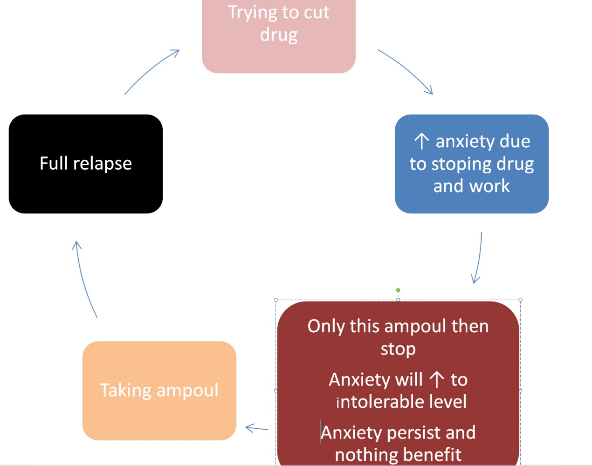

**Intervention:**

-I had only 2 session with the patient:

**-1st session**: in May 2021:

-We did evaluation, then I explained CBT model for his complain and collaboratively we created alternative CBT model as shown in the following figure:

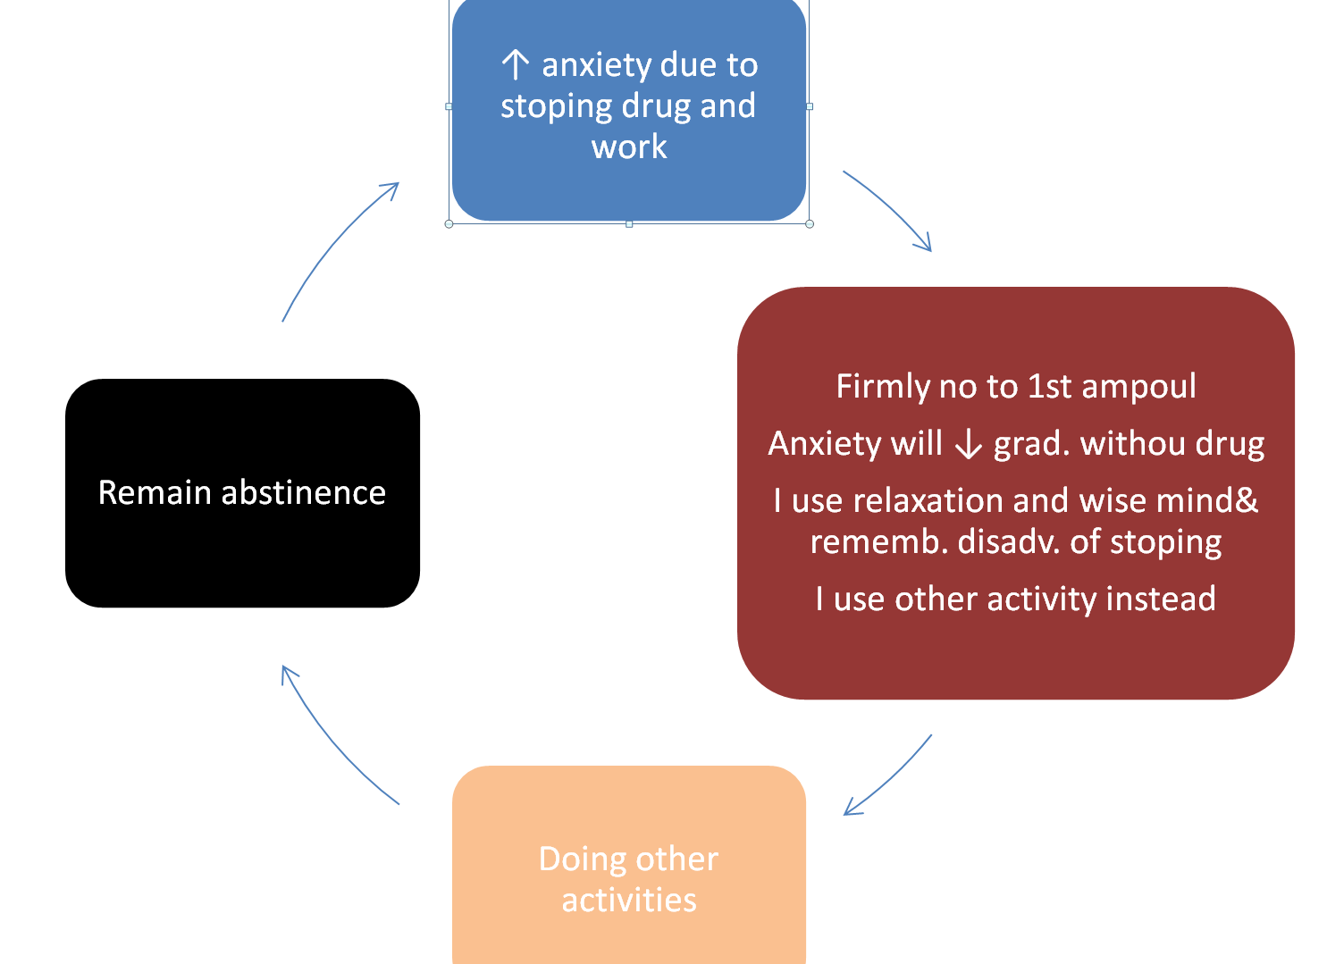

-We determined advantage and disadvantage of continuing and stopping drug taking.

-Then we detected trigger for relapse: stress, guilty feeling and staying alone.

-I suggested that he doing homework between sessions, at least once daily: reading alternative CBT model, reading advantage of abstinence and disadvantage of taking pethidine.

-Because he needed rapid result due to his wife threatening to request divorce if he don’t stop drug taking, so I decided to use hypnosis with him.

-Fortunately he was gifted hypnotic subject, so he enter into very deep trance state in the 1st session.

-During hypnosis, I suggested to him: alternative CBT model, advantages of stopping the drug, and disadvantages of continuing taking drug, also I gave him suggestion about doing the homework.

**-2nd session**: he came after 2 week, and tell me he didn’t use the drug during these 2 week and he want to strengthen what he achieved.

-So I taught him a technique from DBT called wise mind (2) to teach him how to dissociate himself from experience when needed.

-I helped him to enter into trance state and he could went deeper than previous session.

-During hypnosis, I repeat what we did in the previous session, and I added suggestion for using wise mind technique and I used special pattern in hypnosis called high way pattern created by Cal Banyan (3).

-At the end he tell me that he want to come again to learn how to manage his anxiety, but he didn’t.

-After about 15 months I contacted him to take permission for presenting his case in the conference, and he tell me that he didn’t use pethidine again, and he only remember that experience as one of his strengths.

**Causes of success in this case:**

-I think many factors presented in this case that led to this rapid result:

1-He referred to me by big psychiatric figure in Baghdad, so I represented an authority figure for him.

2-I used eclectic approach: CBT, hypnosis and DBT.

3-He had high hypnotizability trait.

4-He had high motivation to change.

**Abbreviations:**

-Hx: history.

-CBT: cognitive behavior therapy.

-DBT: dialectical behavior therapy.

**References:**

1-DeMarce, J. M., Gnys, M., Raffa, S. D., & Karlin, B. E. (2014). *Cognitive Behavioral Therapy for Substance Use Disorders Among Veterans: Therapist Manual.* Washington, DC: U.S. Department of Veterans Affairs.

2-Benjamin J. Sadock, M.D., Virginia A. Sadock, M.D. (2017). Comprehensive textbook of psychiatry. (10th edition).

3-Calvin D. Banyan, MA. (2017). Hypnosis and hypnotherapy patter scripts and techniques. 1st edition.