**CAFFEINATED DRINKS CONSUMPTION BY IRAQI CHILDREN**

**Ziyad Hazim Ibrahim** [1]

**ABSTRACT**

**Introduction:** Caffeinated drinks are popular and they could cause a lot of health problems especially among children. Tea and Cola beverages are considered the common caffeinated drinks in the societies and they are consumed by adults and children. **Aim:** To assess the extent of caffeinated drinks consumption among Iraqi children. **Methods:** A cross- sectional study carried out in Baghdad on 505 Iraqi children to evaluate and look for their consumption of tea and Cola beverages, their related characteristics, and their mothers' concepts and behavior toward consumption of those drinks.  **Results:** Among the enrolled children,83% consume at least a cup of tea and 89.5% a cup of Cola daily.The mean age of beginning the consumption of tea was 20.4 months, while for Cola it was 21.5 months. 66.3% of mothers of those children thought that tea has no benefit for their kids and 17.6% thought that it is very harmful, 51.3% thought that Cola has no benefit, and 45.1% considered Cola generally harmful for their children. 53.8% of mothers had restriction on their children to consume tea or Cola. **Conclusions:** Majority of under-five years Iraqi children consume tea and Cola. The mean age in starting that consumption is below two years. Although the majority of those children's mothers consider tea and Cola with no benefits or harmful, their children still consume those drinks.There is a significant statistical association between children consumption of those caffeinated drinks and imposing of restriction by their mothers on such drinking. **Recommendations:** It is needed to bring an attention on health problems caused by consumption of caffeinated drinks by children, to ban selling of those drinks inside kindergartens, and to encourage mothers to impose restriction on drinking those beverages by their children.

**Keywords:** Caffeine, Tea, Coke, Coca Cola

**INTRODUCTION**

Caffeine (1,3,7-trimethylxanthine) is a central nervous system stimulant alkaloid that is found in various plants such as coffee and cocoa beans, tea leaves, guarana berries, and the kola nut. It can also be synthetically manufactured for use as a food additive, in dietary supplements, and in over the counter or pharmaceutical preparations where synthetic caffeine is identical to intrinsic or plant-derived caffeine. It has been described as the most frequently ingested pharmacologically active food substance in the world. [1] Caffeine intake in children depends on the social context and culture. Although caffeine produces an increase in brain activity, it could hamper growth and development in children.  A lot of studies showed evidence of alterations in children’s growth and development, such as iron absorption deficiencies and weight loss because of caffeine intake. On the other hand, the physical, mental and attention-performance effects of caffeine have been demonstrated in some studies. The negative effects of caffeine on children include changes in the sleep cycle, which could indirectly alter the weight and growth of children, and greater sensitivity to the alkaloid at an emotional level (anxiety and depression). [2] Caffeine consumption in children has received a great interest because of the concern of adverse health effects. It is thought that caffeine intake of 100–400 mg has been associated with nervousness and fidgetiness. There has been some evidence that has linked caffeine intake in children to sleep dysfunction, elevated blood pressure, impairments in mineral absorption and bone health, in addition to increased alcohol use or dependence. [3] The effect of caffeine on children is still under close investigation and its impact on their nervous systems and cardiovascular systems is not fully known. Too much caffeine can cause issues such as increased anxiety, increased heart rate and blood pressure, acid reflux and sleep disturbance. [4, 5]

The maximum allowed caffeine intake stated by Health Canada is 2.5 mg/kg body weight /day for children and adolescents, and 400 mg/day for adults, while it is 3 mg/kg body weight /day for children and adolescents, and 400 mg/day for adults by the European Food Safety Authority. [6] The Canadian government recommends the following daily caffeine limits for kids: Ages 4–6 years: 45 mg, Ages 7–9 years: 62 mg, Ages 10–12 years: 85 mg. In general, children should not consume caffeine more than 2.5 mg /kg body weight per day. [7, 8]

Caffeine is regarded as the most popular psychoactive substance in the world and one of the widest-traded commodities in the forms of coffee, tea, and cola soft drinks. [9] Tea is considered as the most popular beverage, and it is consumed by about two-thirds of the world’s population. [10] In addition, Pepsi, Coke and Coca Cola series are the most popular brands of caffeinated soft drinks in the markets and they are common and most widely consumed. [11, 12] The amount of caffeine in those drinks varied according to the manufacture company and the country of production. In general it is ranging as followings:- instant tea: 20 mg/5 oz. (148 ml) , Nestea: 11.5 mg/12 oz. (355 ml), Lipton: 6.5 mg/12 oz. (355 ml) , Brewed black tea: 47 mg/ 8 oz. (237ml), Bottled tea: 19 mg/ 8 oz. (237ml), caffeinated soda: 37 mg/12 oz. (355 ml), Cola: 18 mg/6 oz. (177 ml), Classic Cola: 29.5 mg/12 oz. (355 ml), Coca: 22 mg/8 oz. (237ml), Coca-Cola: 33.9 mg/12 oz. (355 ml), Diet Coke: 46.3 mg/12 oz. (355 ml), Pepsi: 38.9 mg/12 oz. (355 ml), Diet Pepsi: 36.7 mg/12 oz. (355 ml). [4, 13, 14, 15, 16]

The present study aims to know: (1) the extent of some caffeinated drinks consumption among Iraqi children, (2) their age at beginning of that consumption, and (3) the concepts and conducts of their mothers toward that consumption.

**METHODS**

It is a cross sectional study carried out in some primary health care centers in both sides of Iraqi capital; Baghdad. All under five years Iraqi children who attended the selected health centers were considered as a study population. A convenience sampling was done for children who were attended the above centers throughout three months, so 505 participants were chosen. The mothers of enrolled children were asked about the following: (1) Daily consumption of their children for at least one cup of any type of the following caffeinated drinks: Tea (whether brewed, bags, iced, black, or green), Pepsi or Coca Cola (whether classical, mixed, or diet). (2) Their children's age at beginning of that consumption. (3) Their concepts concerning importance of those caffeinated drinks. (4) Presence of any limitation against drinking of those drinks by their children (the restriction could be achieved either by not serving those drinks for children at home, asking the children to avoid them, or not buying them intentionally) and the reasons for that restriction or not restriction. Tables and figures were executed statistically and presented, and chi- square test was done. Confidentiality was approved for each participant.

**RESULTS**

The count and percentage of the enrolled children concerning their consumption of tea and Pepsi or Coca Cola beverages is illustrated by figure 1 and figure 2 sequentially, while the distribution concerning the beginning of their consumption of those drinks by their mean age is shown by figure 3.

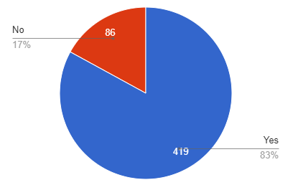

**Figure (1): Count and percentage of the enrolled children regarding their consumption of tea drinks, N=505.**

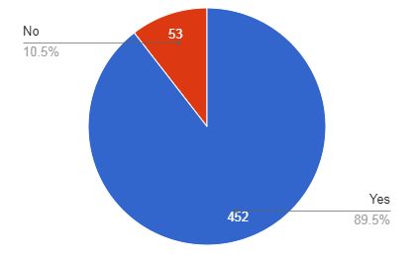

**Figure (2): Count and percentage of the enrolled children regarding their consumption of Pepsi or Coca Cola beverages, N=505.**

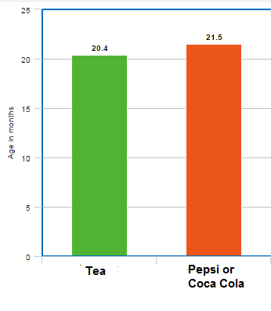

**Figure (3): Means of children ages in beginning of their consumption for tea and Pepsi or Coca Cola beverages (in months), N=505.**

The conceptions of mothers about the importance of tea and Pepsi or Coca Cola drinking by their children are summarized by table 1. The percentage of mothers in restriction of drinking those caffeinated drinks by their children is shown by figure 4, while the reasons of restriction or no restriction of them in allowing their children to drink those drinks are shown by table 2 and table 3 sequentially.

**Table (1): Thinking of mothers about importance of tea and Pepsi or Coca Cola beverages for their children, N=505.**

|  |  |  |
| --- | --- | --- |
| **Concepts:** | **Frequency** | **Percentage** |
| **Thinking of mothers about importance of tea:-** | | |
| No benefit | 335 | 66.3% |
| Very harmful | 89 | 17.6% |
| Warm the body | 37 | 7.3% |
| Little benefit | 15 | 3% |
| Causes anemia | 12 | 2.4% |
| I don't know | 11 | 2.2% |
| Hurts the heart | 3 | 0.6% |
| No benefit no hurt | 3 | 0.6% |
| Total | 505 | 100% |
| **Thinking of mothers about importance of Pepsi or Coca Cola beverages:-** | | |
| Not benefit | 259 | 51.3% |
| Generally harmful | 228 | 45.1% |
| Harm bones | 10 | 2% |
| Not benefit and not harmful | 5 | 1% |
| I don't know | 3 | 0.6% |
| Total | 505 | 100% |

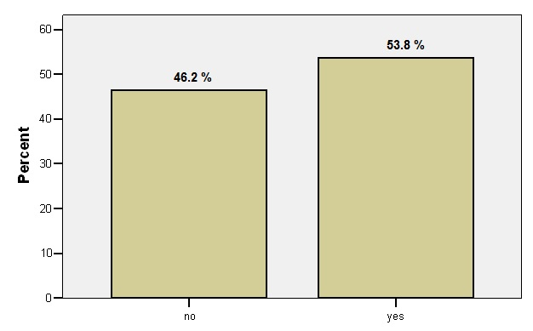

**Figure (4): Percentage of status of mothers in restriction of their children on drinking of caffeinated drinks (tea and Pepsi or Coca Cola beverages), N=505.**

**Table (2): Reasons that make mothers to restrict drinking of tea and Pepsi or Coca Cola beverages by their children, n=271.**

|  |  |  |
| --- | --- | --- |
| **Reason** | **Count** | **Percentage** |
| Those drinks are harmful | 222 | 81.9% |
| Those drinks have no benefits | 49 | 18.1% |
| Total | 271 | 100% |

**Table (3): Reasons that make mothers not to restrict drinking of tea and Pepsi or Coca Cola beverages by their children, n=234.**

|  |  |  |
| --- | --- | --- |
| **Reason** | **Count** | **Percentage** |
| I cannot control my child wish | 220 | 94% |
| My child does not eat except with those drinks | 5 | 2.1% |
| My child drinks only a little of those drinks | 9 | 3.9 |
| Total | 234 | 100% |

The association between status of mothers' restriction on drinking of caffeinated drinks by their children and the consumption of tea and Pepsi or Coca Cola by those children were illustrated by table 4.

**Table (4): Association between mothers' restriction on drinking of caffeinated drinks by their children and the consumption of those drinks, N=505.**

|  |  |  |  |  |  |  |
| --- | --- | --- | --- | --- | --- | --- |
|  | | **Mother's restrict** | | | **Chi-square** | **p-value** |
| Yes | No | Total |
| **Consumption of tea** | Yes | 197 | 222 | 419 | 46.3 | 0.000 **\*** |
| No | 75 | 11 | 86 |
| **Consumption of Pepsi or Coca Cola** | Yes | 225 | 227 | 452 | 28.8 | 0.000 **\*** |
| No | 47 | 6 | 53 |
| Total | | 272 | 233 | 505 |  | |
| **\***: Significant. | | | | | | |

**DISCUSSION**

This study involved 505 children in Baghdad, Iraq. Among them, 419 (83%) consume at least a cup of tea daily, and 452 (89.5%) consume at least a cup of Cola beverage (Pepsi or Coca) daily. These percentages considered relatively high concerning that the studied participants are under five years old and the tea and Cola beverages contain caffeine which could lead to a lot of health problems. Those children had begun the consumption of tea or Cola beverages at early age relatively; the mean age of beginning the consumption of tea was 20.4 months, while for Cola it was 21.5 months. Regarding the concepts of participated children's mothers about benefits of tea, most of them (66.3%) thought that it has no benefit for their kids and less than quarter of them (17.6%) thought that it is very harmful, while regarding the Cola drinks about half of them (51.3%) thought that Pepsi or Coca Cola beverages have no benefit, and more than one third of them (45.1%) considered those beverages generally harmful for their children. It was appeared in the present study that more than half of the mothers (53.8%) had restriction on their children on consumption of tea or Cola drinks, while the others (46.2%) had no such restriction and they allow their kids to drink those caffeinated beverages. When we asked the mothers who restrict their children on drinking of those beverages about the reason, majority of them (81.9%) answered that those drinks are harmful so they do limit their children to consume them. On the other hand when we asked the mothers who do not have such restriction about the reason of allowing their children to drink those beverages freely, the majority of them (94%) answered that they cannot control their children wish!. It is manifested in this study that there is a statistical association between children consumption of both tea and Cola with the presence of restriction by their mothers on drinking of those beverages, so the children consumption of those caffeinated drinks is less if mothers have such restriction than those who had no.

**CONCLUSIONS**

(1) The majority of under-five years Iraqi children in Baghdad consume tea and Cola beverages. (2) The mean age in starting tea and Cola consumption among those children is below two years. (3) Although the majority of those children's mothers consider tea and Cola beverages have no benefits or harmful, their children still consume those drinks. (4) More than half of mothers impose restriction on drinking of tea and Cola by their children, and the most reason among majority of them was because they think that those caffeinated drinks are harmful, while the reason among majority of others who do not have such restriction was because they cannot control their children's wish. (5) There is a significant statistical association between tea and Cola consumption by children with the presence of imposing a restriction by their mothers on drinking of those beverages.

**RECOMMENDATIONS**

(1) It is important to emphasis on educating the community about the health problems related to consumption of tea, Cola and other caffeinated drinks by children -especially under five years old- and to avoid those drinks. (2) It is needed to ban selling of caffeinated drinks inside nursery school, kindergartens and other places in which children care took place. (3) Educating mothers to limit consumption of tea and Cola beverages by their children, and replace them by healthy food and drinks.

**REFERENCES**

1. Turnbull D, Rodricks J, Mariano G, Chowdhury F. Caffeine and cardiovascular health. Regulatory Toxicology and Pharmacology. 2017; 89: 165-185.

2. Torres-Ugalde YC, Romero-Palencia A, Román-Gutiérrez AD, Ojeda-Ramírez D, Guzmán-Saldaña RME. Caffeine Consumption in Children: Innocuous or Deleterious? A Systematic Review. International Journal of Environmental Research and Public Health. 2020**;** 17(7):2489.

3. Ahluwalia N, Herrick K, Moshfegh A, Rybak M. Caffeine intake in children in the United States and 10-y trends: 2001–2010. The American Journal of Clinical Nutrition. 2014; 100 (4): 1124–1132.

4. Johns Hopkins All Children’s Hospital. General News- Is Coffee Bad For Kids. United States. 2022. [Internet] available at: https://www.hopkinsallchildrens.org/ACH-News/General-News/Is-Coffee-Bad-for-Kids#:~:text=Children%20and%20adolescents%20are%20also,acid%20reflux%20and%20sleep%20disturbance.

5. Bernstein G, Carroll M, Crosby R, Perwien A, Go FS, Benowitz N. Caffeine Effects on Learning, Performance, and Anxiety in Normal School-Age Children, Journal of the American Academy of Child & Adolescent Psychiatry. 1994; 33(3): 407-415.

6. Verster JC, Koenig J. Caffeine intake and its sources: A review of national representative studies. Critical Reviews in Food Science and Nutrition. 2018; 58(8): 1250-1259.

7. Child's Health. Children's Hospital Association. Health and Wellness Library- Caffeine and kids: What to know to keep your child's heart healthy. Unites States. 2022. [Internet] Available at: https://www.childrens.com/health-wellness/caffeine-for-kids.

8. Nawrot P, Jordan S, Eastwood J, Rotstein J, Hugenholtz A, Feeley M.  Effects of caffeine on human health, Food Additives & Contaminants. 2003;  20(1): 1-30.

9. Jack E James. Understanding caffeine: A biobehavioral analysis. United States: Sage Publications; 1997.

10. Khan N, Mukhtar H. Tea and health: studies in humans. Current Pharmaceutical Design. 2013; 19(34): 6141-6147.

11. Hu D, Cheng L, Jiang W. Sugar-sweetened beverages consumption and the risk of depression: A meta-analysis of observational studies. Journal of Affective Disorders. 2019; 245: 348-355.

**12.** Lozano-Calero **D,** Martìn-Palomeque **P**, Madueño-Loriguillo **S**. Determination of Phosphorus in Cola Drinks. Journal of Chemical Education**.** 1996**;**  73 (12)**:** 1173.

13. Barone J, Roberts H. Caffeine consumption. Food and Chemical Toxicology. 1996; 34(1): 119-129.

14. McCusker R, Goldberger B, Cone E. Caffeine Content of Energy Drinks, Carbonated Sodas, and Other Beverages.  Journal of Analytical Toxicology. 2006; 30(2): 112-114.

15. Mayo Foundation for Medical Education and Research. Mayo Clinic. Healthy Life Style, Nutrition and Healthy Eating. United States. 2022. Available at: https://www.mayoclinic.org/healthy-lifestyle/nutrition-and-healthy-eating/in-depth/caffeine/art-20049372.

16. Chou KH, Bell LN. Caffeine content of prepackaged national-brand and private-label carbonated beverages. Journal of Food Sciences. 2007; 72(6): 337-342.

1. : Specialist in Community Medicine, Iraqi Ministry of Health , Baghdad , Iraq.

   Tel.: 009647901998801 , E-mail: drziyad2005@gmail.com